Post-event report
North Sea Energy Summit 2026 · 22–24 September 2026 · Booth B4.210
Noah Fischer · 01 October 2026 · WE-MC-EVT-2026-02
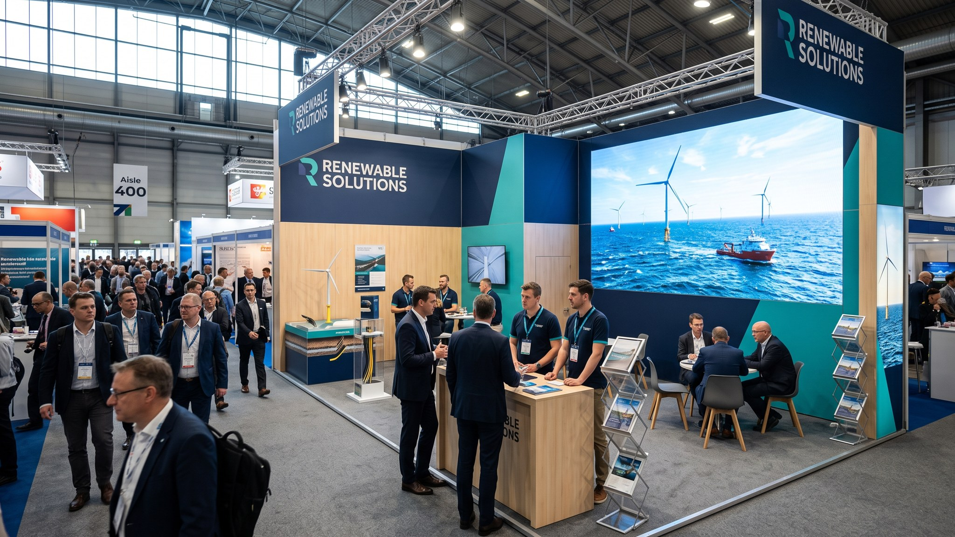

Summary
Our first own stand at the North Sea Energy Summit 2026 was a clear success. We held 642 conversations at booth B4.210, scanned 142 leads (27 rated A) and ran 38 pre-booked meetings. Dr. Amara Okafor's keynote 'From steel to sea' filled the Main Stage with around 850 people and was quoted in 11 articles. Total cost was EUR 176,000 against a budget of EUR 185,000.
KPI | Target | Result
Qualified leads | 120 | 142 | ✔
A-leads | 20 | 27 | ✔
Pre-booked meetings | 35 | 38 | ✔
Candidate conversations | 60 | 71 | ✔
Applications (until 1 Oct) | 30 | 24 | ✘ (still coming in)
Keynote audience | 700 | ~ 850 | ✔
Media mentions | 25 | 41 | ✔
Cost per lead | EUR 1,540 | EUR 1,239 | ✔

Booth traffic
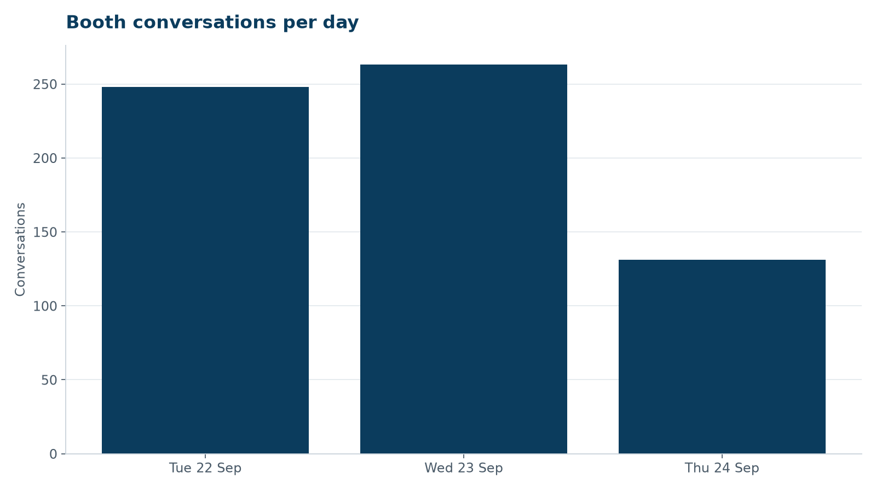
Conversations per day (lead app + counter tally).
Wednesday was the strongest day thanks to Elena Márquez's panel at 14:00 and the careers hour. The turbine model was the most photographed object on the stand – many visitors came because colleagues had posted it on LinkedIn.

Leads
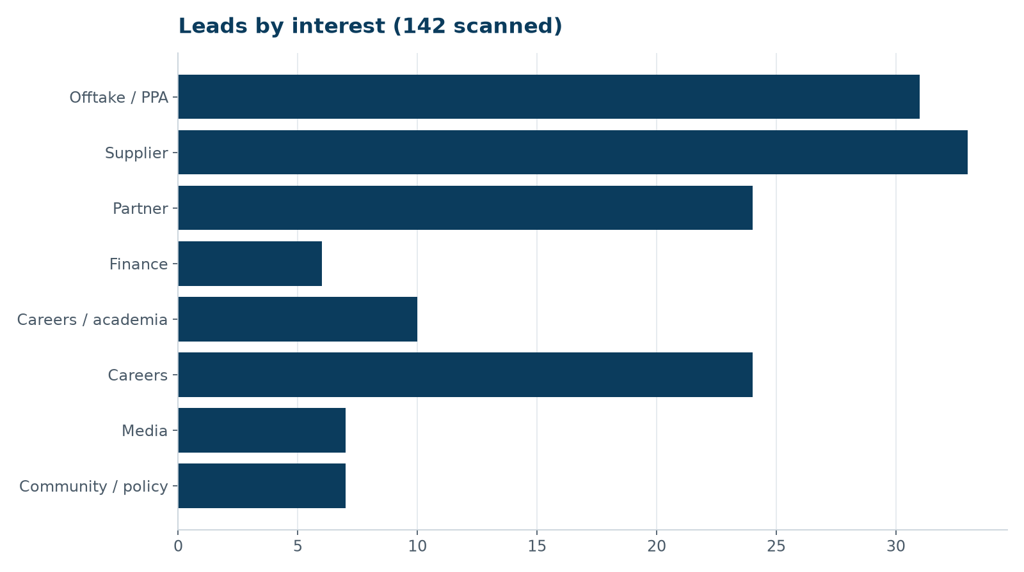
The most valuable conversations were with industrial offtakers: three energy-intensive companies want to discuss PPAs from 2029 onwards, and Arcturus Steel raised a possible second tranche. All A-leads have an owner and a follow-up date in the tracker; target is first contact within ten working days.

Keynote and panel
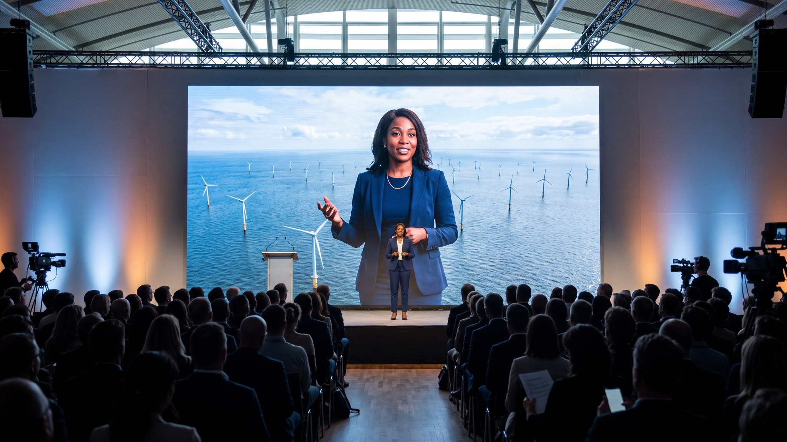
Dr. Amara Okafor on the Main Stage, 22 September.
The open account of the cable delay as 'lesson 1' was well received – two journalists mentioned the transparency explicitly. The panel 'Delivering offshore wind on time' (Wed 14:00) had 230 attendees.

Budget
 | EUR
Budget | 185,000
Actual (invoices received to 1 Oct) | 176,000
Under budget | 9,000

What we will change next time
- Book the stand in the same position (aisle 21) – the location was excellent
- One more person on reception on Tuesday morning (queue at 10:00–11:00 after the keynote)
- Order 30 % fewer tote bags, twice as many seed paper cards
- Second LED loop focused on careers – the careers wall was too small
- Lead app training one week earlier; on day 1 about 20 conversations were not scanned

Recommendation
Exhibit again in 2027 with the same modular stand (re-use saves an estimated EUR 38,000) and apply for a keynote slot early. Decision by the Executive Board in October.

